PreconfigComponent Name 🡪 means its calling from base only

ProvidedDataInterface🡪 is used for configuring data through ui It have entity name 🡪if we not giving ProvidedDataInterface in component file we are getting error

AttributeMetaData🡪is used to define the entrykey -🡪 we are defining attributes in entity class that we can map in component.xml file &🡪 in that we are using map merge=ture

PathToEntityField-🡪name should be same as we define in entity class

We define 1 private attribute in entity class but we don’t need to persist data-🡪 we use @transient annotation in hibernate

providedConnectionPoint -🡪 in that we are defining the relationship like one to many many to many

autowired 2 multiple 2 spring name --🡪we can use @Autowired Annotation

Quote -🡪 means when we are creating a policy that time we need to give all details to the insurer means we create a quote like initial stage to collect all the details before buying the quote

The initial status of quote is -🡪initial

1 policy have multiple coverages

Propose -🡪 we are giving the notification to the customer

Bind the policy -🡪 then status is bound🡪then you can issue the policy

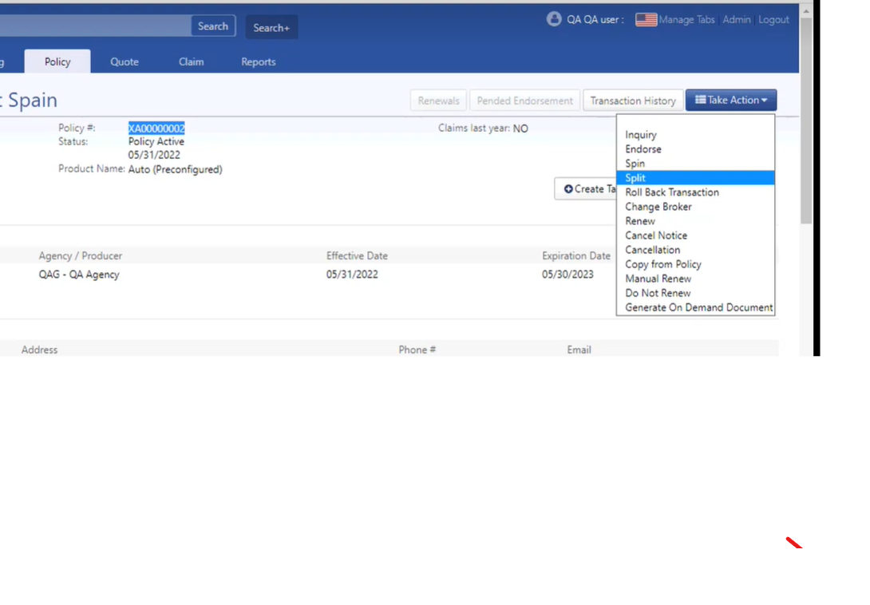

After issuing policy -🡪 policy status is Active and we see other options to perform operation

If we issue the policy and we need to add or edit some information then we can do --🡪endorsement the policy -🡪but before we need to renew the policy-🡪endorsement date is after policy effective date

Transcation History -🡪 in that we see the all transaction we perform in that policy

If we are doing copy from policy then we give the effective date is after the transaction effective date &-🡪 also we need to change the plate number

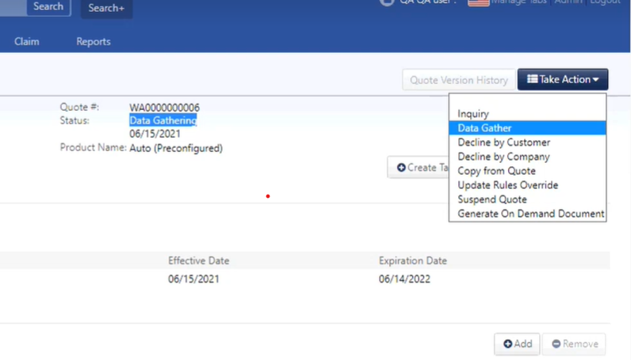

Then we see the other operations to perform

Cancellation date should be same as transaction effective date-🡪 after cancel the policy we can see all these operation to perform

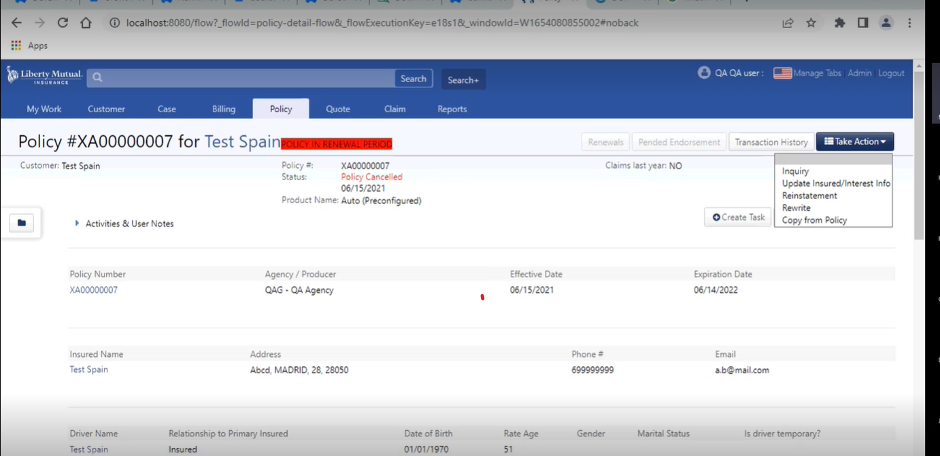

After perform rewrite operation we see these operation to be performed

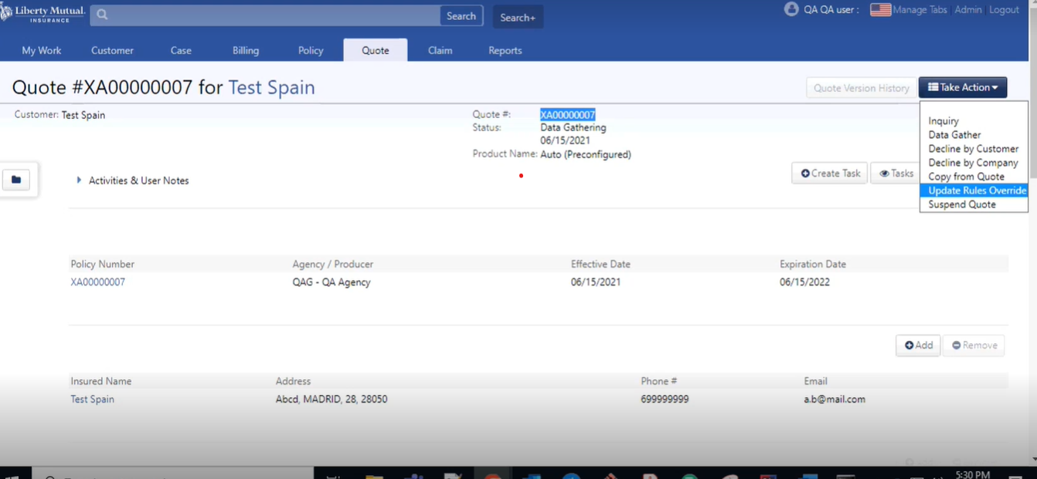

After rewrite the policy then we go data gather -🡪 calculate premium and coverage--🡪 again policy is in active state we again we see other operations to be performed

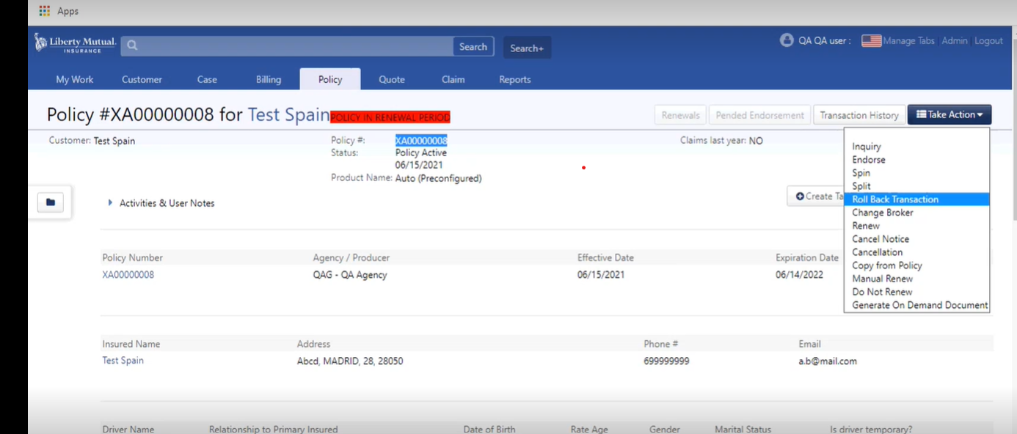

After again we perform cancel the policy then cancellation date should be different

Again policy is in cancel then show the options

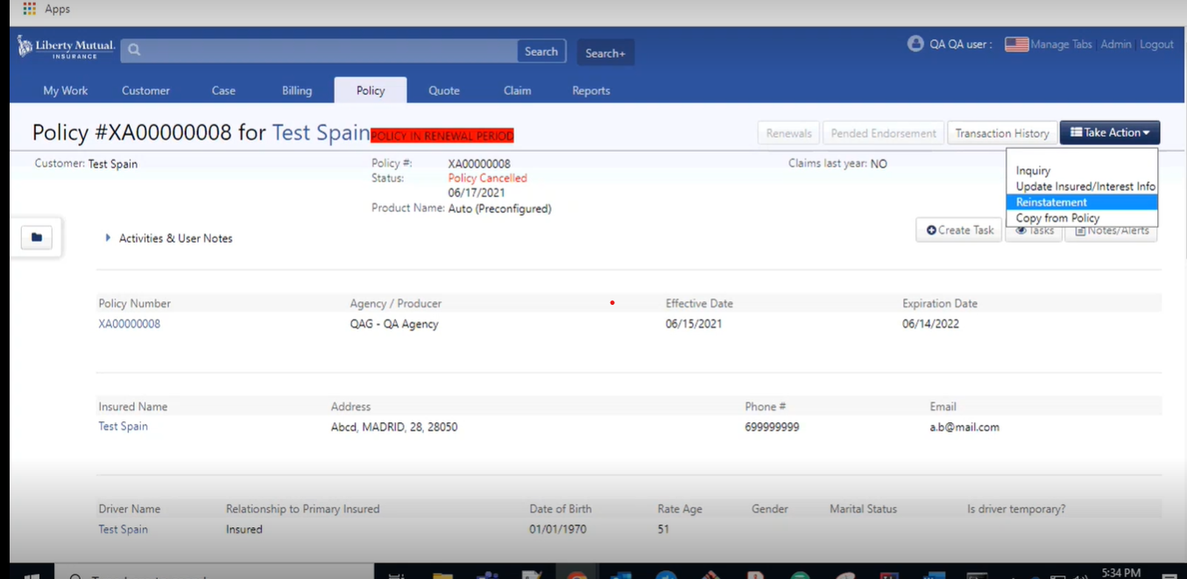

Policy effective date same as cancellation date --🡪 flat cancellation

Creating new rule

Creating rule in admin side--🡪 first go to the admin and deactivate the product -🡪 go to the rules section--🡪 search for the component --🡪 & then click on create a rule --🡪applied to in that give the component name.attribute name-🡪give the description--🡪Asseration expression----- -🡪condition expression gives true and also we check the checkbox for required -🡪 if I want to give some condition like we give condition like we can see these attribute required only for the spain customer then we give the condition in condition expression policy.contryCd==’ES’--🡪if I want to call a java method then write applicationContext.extendedAutoBlsRules.methodname(pass the componentName.attributeName)

Default value Expression--🡪 in that we have to show any default value in ‘’ “ in ui then we can use these

We need to write a rule in codebase side also --🡪 write a logic in ExtendedAutoBlsRules.java class and run dbconfig and core and then configure the rule in admin side

What is the applicationContext--🡪applicationContext is used for mapping the bean

Asseration Expression -🡪 like a if condition (like the if condition is fail then error then it shows the error message in error message block)

Add Event Listener --🡪If we want to fire the rule while clicking on add buttom then we need to add a Listener in admin

First go to admin-🡪go to component tab go down -🡪there is option set validation-🡪click on that--🡪give the name of Listener &--🡪 click the option --🡪publish before new component instance is added

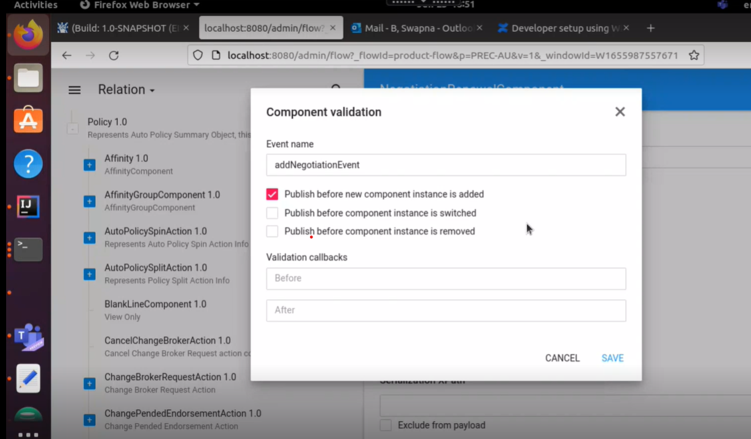

**LookUps---🡪**lookup is used to stored a fixed value and which can be displayed in ui

Roles & Privilieges --🡪 1 role can have multiple privileges(role is collection of privileges)

For creating role and privileges e need to create 2 file for that 1 for role and 1 for privileges and also we need to create 1 file for changeset

**Packages----🡪** packages have good number of coverages

RAW-🡪 Base premium

**Override Xhtml base file--🡪**For that we need to create a xhtml file and give the reference in component.bean.xhtml file like that

**<property name="views">**

**<map merge="true" key-type="com.exigen.ipb.components.domain.ViewType" value-type="java.lang.String">**

**<entry key="dataGather" value="/policy/preconfig/components/EuropeTestComponent_1_0_edit.xhtml" />**

**</map>**

**</property>**

override the xhtml is use to achieve a search filter in lookup for that purpose we are creating customize xhtml file

If we want to add any feature like search filter ,Boolean field ,inputtext field then we can introduce override base xhtml file **only for spain only it shows the filter**

If we comment out the changes then it loads from base class that comes in views property tag in component.bean.xhtml file

consolidatedView--🡪

**Claims**